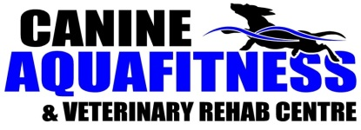
Join us for a
Hands-On, Small Group Workshop
Canine Massage Foundation

Saturday, June 22nd, 2019
2:30 – 4:00 p.m.
Canine Aquafitness & Veterinary Rehab Centre
98 Elizabeth St., Okotoks

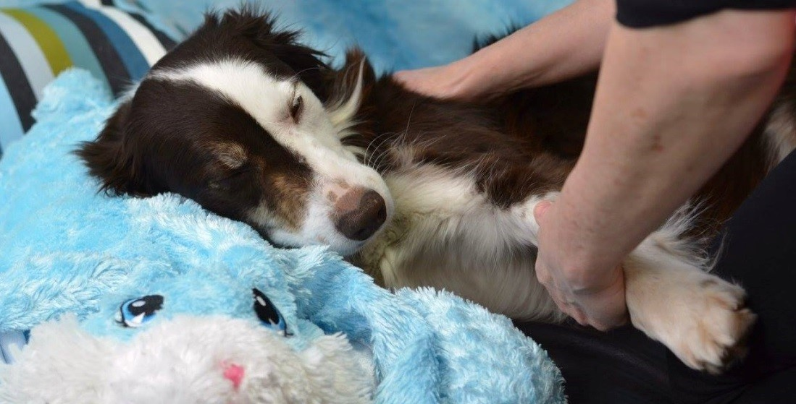
Massage Provides Many Benefits:
* Pain Relief * Improves gait & balance
* Enhances flexibility & range of motion
* Helps calm and build trust in dogs with behaviour issues

Register online today! Space is limited!

www.canineaquafitness.ca Ph: 587.364.3211

